Sharon’s DB - Testing Database

SQL to check the tables

EVIDENCE REQUIREMENT

1. A COPY OF THE SQL CODE THAT COMPLETES EACH OF THE REQUESTED QUERIES
2. THE OUTPUT SHOWING THE RESULT FROM RUNNING THE QUERIES – USE SNIPPING TOOL TO SHOW THE OUTPUT

Q1. Check that each table will display the output presented in the individual tables

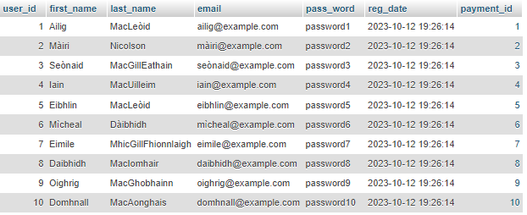



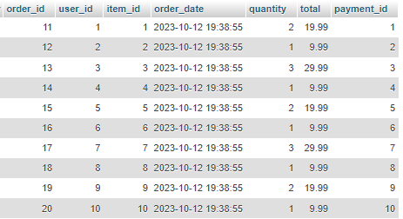



Q2. Show the output from two of the adjacent tables in turn – that is orders and users; orders and item.



Q3. Connect all three tables and display the output that shows the output from these three tables – users, orders and item.

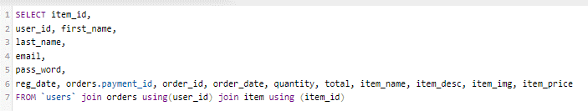

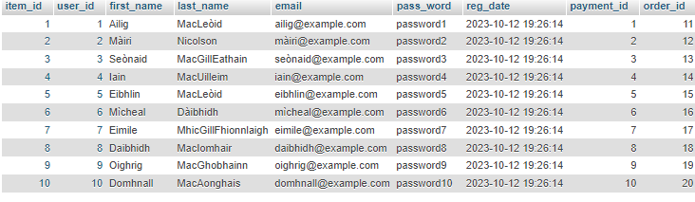

Q4. Create a query that will show the users and payment – so link these two tables and produce the output.



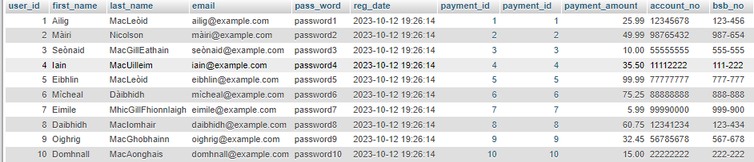

Q5. A manager wants to show a catalog of the items in the system and there quantities.



